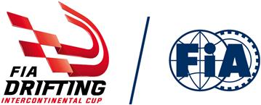

Entries open for 2019 FIA Intercontinental Drifting Cup

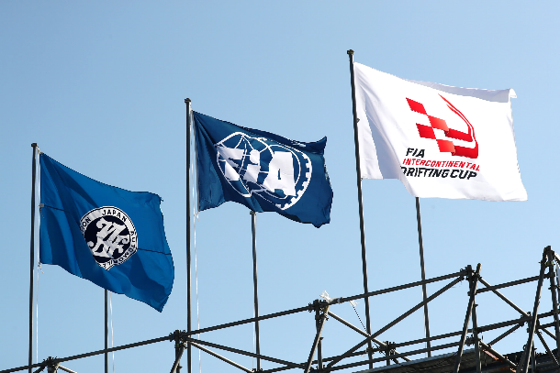
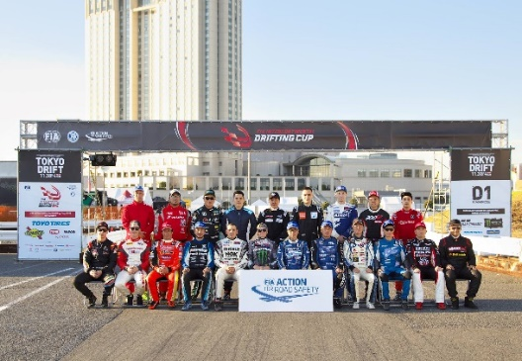
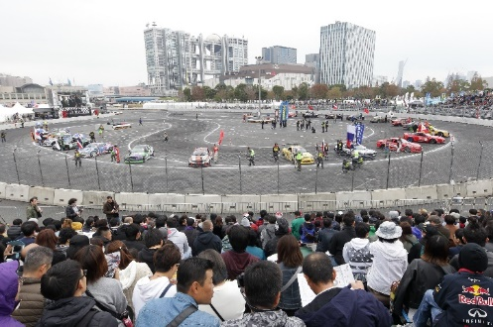
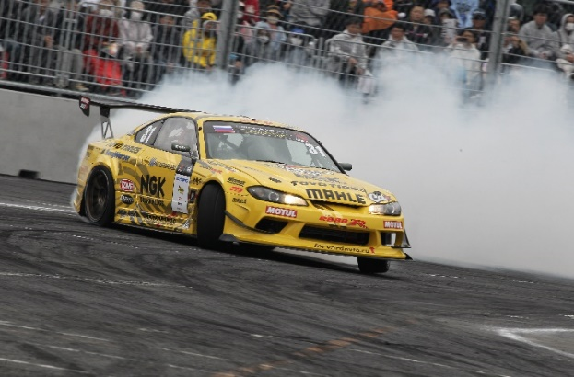
The FIA has announced that entries for the 2019 FIA Intercontinental Drifting Cup will open on Monday 3rd June with the event promotors Sunpros creating an attractive package for potential competitors.

After two events at a temporary venue in Tokyo, the third edition of the event moves to the famous Tsukuba Circuit a short distance north of Japans capital city where competitors will be able to enjoy three days of competition from the 29th November through to the 1st December. The amount of track time for drivers has been greatly increased to specifically provide the best experience for international drivers coming to the event.

The entry fee per car will be US$3,500, with that fee including the cost of round trip seafreight of the competition vehicle to Japan from a competitor’s home country, as well as event passes and insurance for three people. A total prize fund of approximately €15,000 is up for grabs, with the overall winner of the event also earning an invite to the FIA’s Gala Prize Giving in Paris where they will receive their trophy alongside the stars of Formula One, WRC and the various other FIA competitions.

Competitors will also benefit from a new event format that is being debuted this year, which will see a “Bottom 16” Battle Tournament run on the Saturday afternoon to enable those who have qualified poorly a last chance to qualify for the main tournament the following day. While only the winner of the “Bottom 16” tournament will proceed to the final competition, this format will both provide additional entertainment for spectators as well as ensure that all competitors get to compete in at least one battle match, irrespective of their performance in qualifying.

As part of the efforts to put together the best event possible, the FIA has appointed three of the world’s most respected Drift Judges to the event. The appointed Judges for the 2019 FIA Intercontinental Drifting Cup will be Hisashi Kamimoto of Japan, Canadian Ryan Lanteigne and David Kalas from the Czech Republic. Sporting Regulations for the event can be found on the FIA website and are subject to the approval of the FIA World Motorsport Council on the 14th June.

The deadline for submission of entries will be at 12:00 (UTC) on the 18th August 2019. Following that, the selection committee will review all applications and publish the entry list the entry list in September.

“We believe that this years event will be the best yet and we hope to be able to attract more competitors from beyond Asia to come take part”, stated Sunpros CEO Isao Saita. “We have also worked hard with both the FIA and the various international drifting promotors in order to schedule this years event after the conclusion of each major championship in order to enable greater international participation. We look forward to welcoming drivers from across the world to Tsukuba this year”.

The FIA Intercontinental Drifting Cup was founded in 2017 as the first ever Drifting event to be run under FIA regulations and the 2017 and 2018 editions were held in the Odaiba district of Tokyo. For the 2019 edition will be held at the famous Tsukuba Circuit from the 29th November to the 1st December.

The 2017 event was won by Masato Kawabata of Japan, with Russian driver Georgy Chivchyan taking the win in 2018.

- END -

Official Web Site: www.fiadriftingcup.com
Media Contact: press@fiadriftingcup.com

About the FIA

Founded in 1904, the FIA’s initial aim was to bring coherent governance and safety to motor sport.
The FIA has since grown into a global organization that not only promotes motor sport, but also safe, sustainable and accessible mobility for all road users across the world. As such, the Federation works across three key interlinked areas of activity – Sport, Campaigns and Mobility.

About the SUNPROS

SUNPROS’s predecessor company was a Japanese automobile magazine company that has been in operation since 1947. Then started a business using video contents as a product from 1988, and started drift competition since 2001. This became the first drift competition in the world, and eventually spreads to the world.
Currently it operates the D1 Grand Prix, and is the cutting edge of drift competition development with the Japan Automobile Federation (JAF).

